PHASE 1: Requirement Analysis & Planning
The school IT helpdesk receives various support requests from students and teachers every day. These requests generally involve network connectivity, hardware failures, account access, and system performance.
At present, IT staff manually review each ticket to:
- Identify the issue type.
- Select the correct category and subcategory.
- Inform the caller about ticket creation.
This manual approach can be time consuming and prone to classification errors. It also becomes difficult to manage efficiently as the number of requests increases.
The proposed workflow addresses this issue by using predefined keywords and category rules, so similar requests are handled in a consistent manner.

Activity 1: Business Use Case

Business Requirements:
The proposed system should:
1. Automatically classify IT tickets according to the issue description.
2. Assign both Category and Subcategory automatically without manual intervention.
3. Maintain a dependent choice relationship between Category and Subcategory.
4. Send an automated email notification to the caller after ticket creation.
5. Store ticket details in a structured and standardized format.
6. Keep the solution easy to maintain and suitable for future expansion.
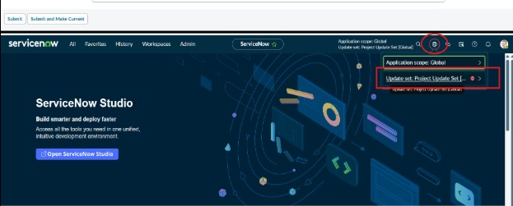

Activity 2: Create a New Update Set

Navigation Steps:
- Open All menus → Search for Update Sets.
- Under System Update Sets, select Local Update Sets.
- Click the New button in the top right corner.
- Name: Project Update Set.
- State: In progress.
- Application : Global.
- Save the form.
- Under Related Links, click Make This My Current Set.
- The created update set will then be displayed as the current update set.
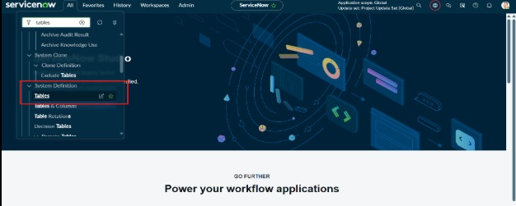

Activity 3: Navigation Steps in Picture View

